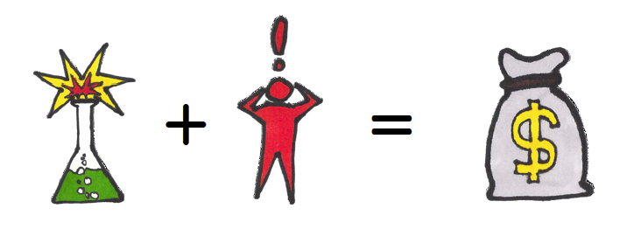


Founding members can join now!

Have an idea for a Science Fair Project? ‘
Not sure where to start?
Check out the Science Fair Schoology Group!

- Teachers are here to help with your project!
- No commitment for joining!
- This group will offer a growing collection of ideas and things related to making an AWESOME science project!
- All grade levels are welcome!
- Science Fair in January – Regionals in February / March
To join:
    - Just log in to Schoology
    - Click ‘Groups’ at the top left

    - Select ‘My Groups’ on the right
    - Select ‘Science Fair’ under the ‘School Groups’ tab
    - Click to request to join – its easy!

- Ask questions by posting them to the group
- Other questions? Email hblythe@ecusd7.org
- All new members will be awarded a Founding Member Badge on their Schoology account!

