Digital Content for Students
Adapted from the teacher’s 2019 digital content manual

Schoology
- Schoology is a learning management system, or LMS, that students at Edwardsville High School began using during the 2018-19 school year.
- An LMS is a web-based program that organizes and houses the digital content a teacher would like students to access for their course.
- Schoology can be used for homework, class assignments, calendars, work submission, classroom discussions, etc.
- Students can also complete and submit assignments to the teacher online.

Clever
- Clever is a portal that will allow District 7 students to access one location, enter their unique username and password, and have access to all of their digital content
- Edwardsville District 7 has its own Clever Portal, and the student must use their unique Clever account to access the digital content associated with their classes
- Using your Chrome Browser, go to the District 7 Clever Portal: https://clever.com/in/ecusd7

Curriculum-Based Content
- Students have access to digital textbook and content for their mathematics and science courses
- All course-based content can be accessed via a Chrome browser through the secure District 7 Clever Portal at https://clever.com/in/ecusd7
- Science classes will use the TEXTBOOK: Pearson Elevate Science, Course 2
o Students will use the DIGITAL PLATFORM Savvas to access their content
Student Computer Login Process
Access to District 7 Computers and all Digital Content

PROCESS FOR BEGINNING OF THE SCHOOL YEAR

- K – 8 buildings will receive their bulk student password list on the first day of school
  - ALL students in grades K-12 will use their unique login ID and password to login to any District 7 computer.
  - A nightly sync occurs between eSchoolPlus and Clever (and all other digital content connected through Clever).
  - The student may then use the login from school or home to access their digital resources through Clever.

Continue on the next page

TO ACCESS CLEVER:

STEP 1: Using your Chrome Browser, go to the District 7 Clever Portal: https://clever.com/in/ecusd7 • There is also a Clever shortcut on your desktop.
• You can also use the link on the District 7 Website: http://ecusd7.org/parents/digital-resourcesasp/ and choose “Clever” to login.
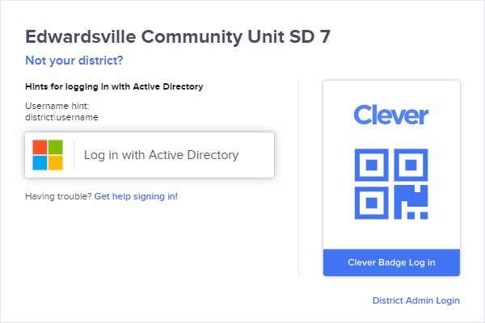

STEP 2:
Choose Login with Active Directory

CONTINUE on the next PAGE
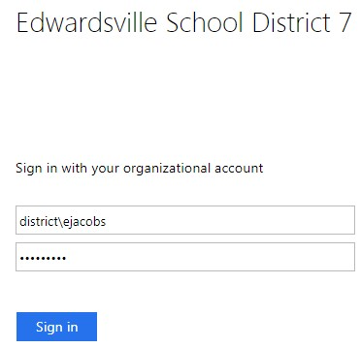

STEP 4: You should now be on the Clever home screen, which will allow a user to choose the content they are interested in viewing.

Math Science Typing

6 8:

Math (Grade 6 and Grade 7 & 8 Accelerated Only)
Publisher: Cengage Learning
Textbook: Big Ideas Math
Digital Platform: Big Ideas Math (accessed via Clever)
CONTINUE on the next page

Math (Grades 7 & 8)
Publisher: McGraw-Hill/Glencoe
Textbook: Glencoe Math
Digital Platform: ConnectEd (accessed via Clever)

Science
Publisher: Pearson
Textbook: Pearson Elevate Science
Digital Platform: Savvas – formerly Pearson Realize (accessed via Clever)

TO ACCESS CLEVER:

STEP 1: Using your Chrome Browser, go to the District 7 Clever Portal: https://clever.com/in/ecusd7 • There is also a Clever shortcut on your desktop.
• You can also use the link on the District 7 Website: http://ecusd7.org/parents/digital-resourcesasp/ and choose “Clever” to login.

STEP 2:
Choose Login with Active Directory

→

STEP 4: You should now be on the Clever home screen, which will allow you to choose the content you are interested in viewing. For science class, select Savaas (Pearson EasyBridge)

CONTINUE TO NEXT PAGE 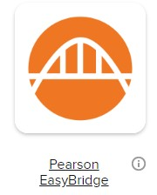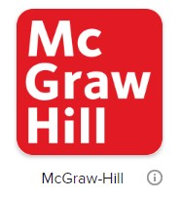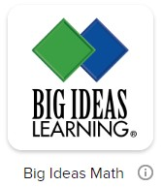

Digital Troubleshooting (for Students & Parents)

If you and your child are having trouble accessing the digital content from home, please answer the following questions prior to notifying your child’s school.

Troubleshooting Steps:

- Are you using Google Chrome as your browser?
- Are you accessing Clever using the District 7 Portal?
  - https://clever.com/in/ecusd7
  - Parents can use the link on the District Website (assuming the default browser is
Chrome) : http://ecusd7.org/parents/digital-resources-asp/
- When you enter your child’s username, do you have district\ in front of the username?
- If you were able to login to Clever, is the icon you are looking for available?

 | K – 2 | 3 – 5 | 6 – 8 | 9 – 12
MATH | 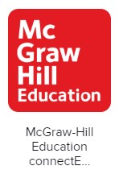 | 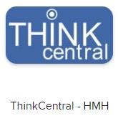 | 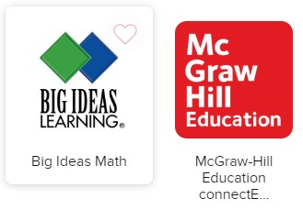 | 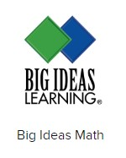
SCIENCE | 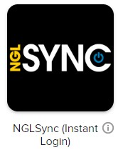 |  | 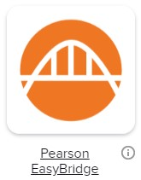 | Various textbook / publishers s are used throughout the Science department at EHS. If you do not see an app for your textbook, contact the teacher of the course.
ENGLISH |  |  |  | 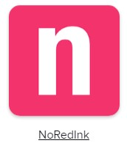

You should be able to answer “YES” to all of the questions above. If you have answered all the questions “yes” and are still unable to access the digital content, please contact your child’s school with the following information:

- Your name
- Student Name
- Student Grade
- Confirm the questions above have all been answered “yes”, OR inform the school where your login issues are occurring.

