Student Handout-
Using Savvas Realize for Science Class


Watch tutorial Videos at this link: https://mysavvastraining.com/products/realize/tutorials
Select ‘Student’ then watch videos over these topics:
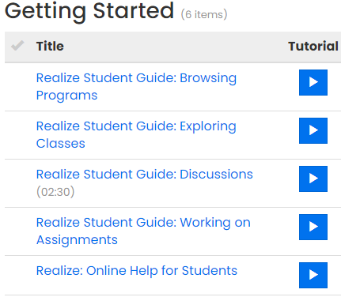

Reminders about using Savvas Realize from home or school

- Use Chrome to navigate to the district page www.ecusd7.org
- Locate the Students tab (upper right) & select Clever from dropdown menu
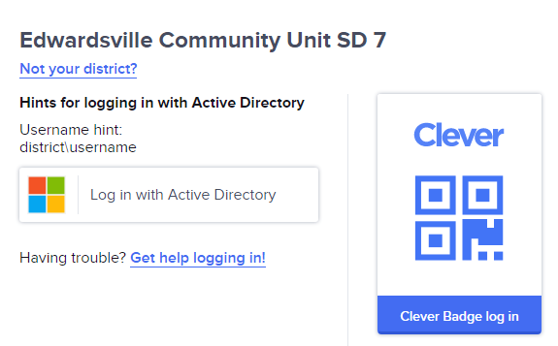
Log in with Active Directory.

- Use your unique Username & Password (provided to you on your first day of in-class instruction or emailed by your remote teacher) to log in on this screen:
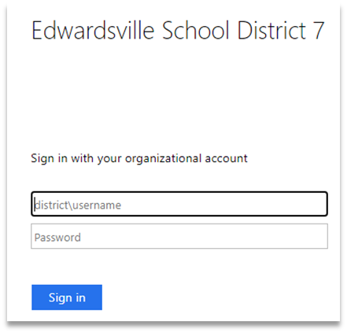

You MUST type in district\
BEFORE entering your
user name

- Once you log in, you will see this screen:

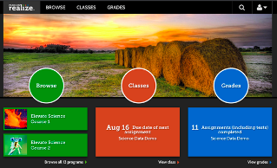

- Click the ORANGE CIRCLE called CLASSES in the middle to access your science class

- Once you click classes, you will see 3 tabs

Not started In progress Completed
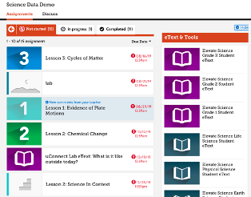

Details about each tab are on the next page > > >
What does each tab mean?

NOT STARTED. Work assigned by your teacher is here. Click on the name of assignment to work on it.

IN PROGRESS. Once you open an assignment, it is classified as ‘in progress’ and will remain under the in progress tab until you turn it in. It is critical that you submit all assignments to receive full credit.

COMPLETED. Once you have turned in work, it is moved to the Completed tab. You might get grade feedback or points on Savvas Realize, but you will not see an accurate grade. Savvas points do not reflect work completed on Schoology. Points may transfer differently between programs (as determined by teacher). Check Tiger View to view your current science grade.

Completing Assignments

- When you click on an assignment, multiple items may show up. If they do, you can go into the items in any order.
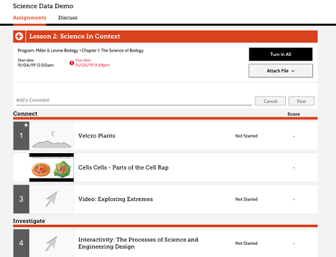

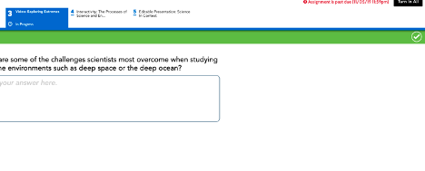
- When you work on an individual item, you can turn this individual item in when you are finished by clicking on the green check mark in the corner.

- If other items are assigned, you can work on the other items. When you return to the main screen on the assignment, you will see a TURN IN ALL button in the top right:

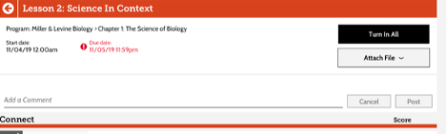

If you are done with ALL items, click TURN IN ALL. This will turn in all pieces at one time.

- You can attach items here, send the teacher comments, or read teacher comments.

For more help, watch the tutorial videos (see the link at the top of this handout).

